VISUAL STORY GUIDE:
Purchasing Tickets
Over the Phone
or
In Person

Table of Contents

Purchasing Tickets Over the Phone………………………………………………………………. 3
Purchasing Tickets in Person in advance
At Rainbow Stage Administration Office……………………………………………… 4
At Rainbow Stage inside Kildonan Park……………………………………………….. 11

Introduction

Welcome to Rainbow Stage’s visual story guide to purchasing tickets over the phone or in person. This guide is designed to make the process easier for first time buyers, care workers of patrons who may need assistance with the process, or patrons who are unfamiliar or are less comfortable with the buying process.

In this guide you will find visual representation as well as detailed descriptions of the process of buying tickets over the phone or in person.

Rainbow Stage welcomes patrons of every kind. We are excited to have you attend our productions and we hope you find this guide helpful when making your purchase.

If you have any questions, concerns or suggestions, our box office staff will be more than happy to assist you. 204-989-0888

Purchasing Tickets Over the Phone

There are two numbers you can dial to reach a box office agent.

- 204-989-0888

- Toll Free 1-888-908-0888

Both of these numbers will bring you to the same box office agents.

The person assisting you over the phone will require the following information from you when purchasing tickets over the phone.

- Your full name

- Your telephone number

- The mailing address associated with whatever credit card you are purchasing with. This includes postal code.

- What show and what date you’d like to attend?

- Do you require wheelchair accessible seating?

- What price range would you like to purchase?

- A VISA or MasterCard number, expiry date, and CVV (the CVV is the 3 small numbers located on the back of the card above your signature line.) Once the agent puts the payment into our ticketing system, they are no longer able to see your personal payment information.

- The box office agent will ask if you’d like to have your tickets emailed to you, sent to via mail ($2.00 charge) or if you’d like to pick them up.
Purchasing Tickets In Person at
Rainbow Stage Administration Office

Purchasing Tickets November through July

Rainbow Stage’s administration office is located at 202-1215 Henderson Hwy, on the second floor.

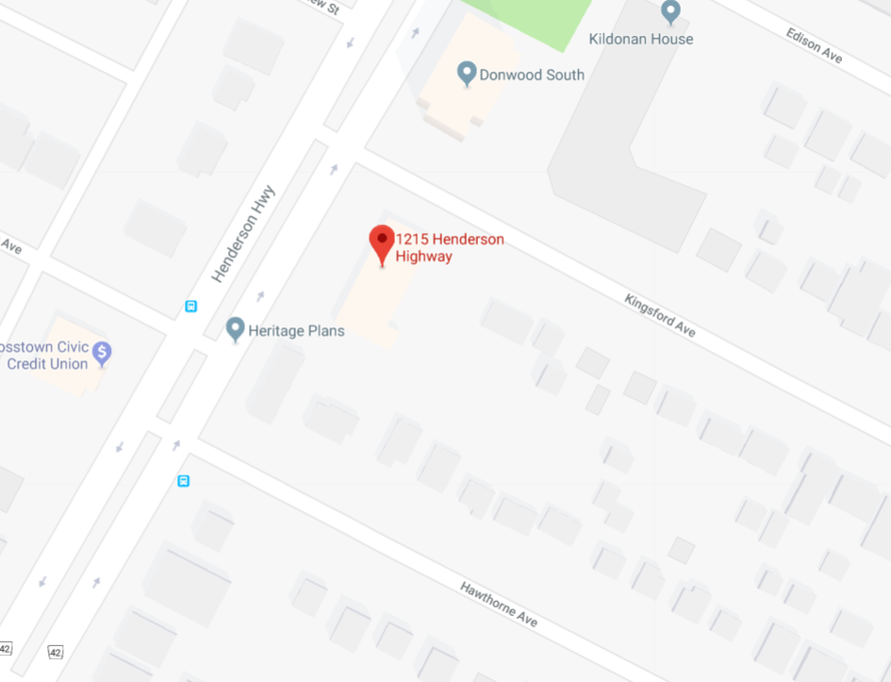

The Rainbow Stage Office is open Monday to Friday between 9am and 5pm.
There is free parking for visitors.
There is no elevator.
If you are unable to take stairs, please call 204-989-5261 and press 0.
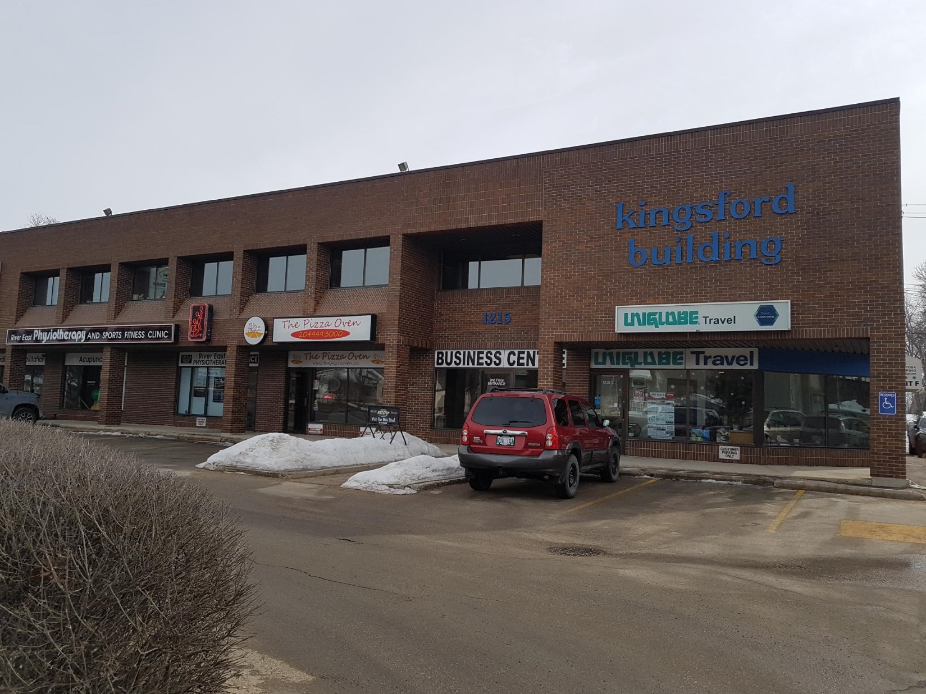

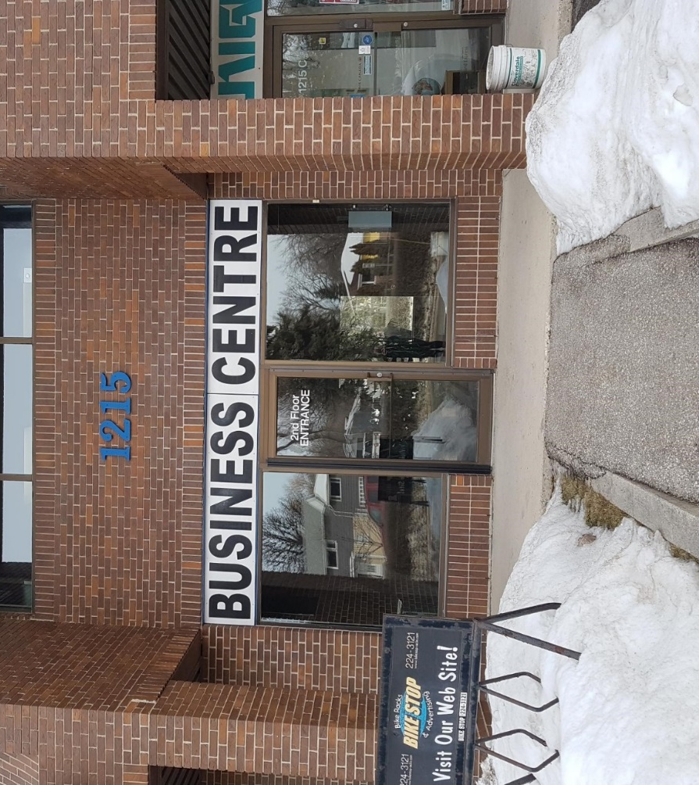
Enter Here. Inside these doors you will see a set of stairs

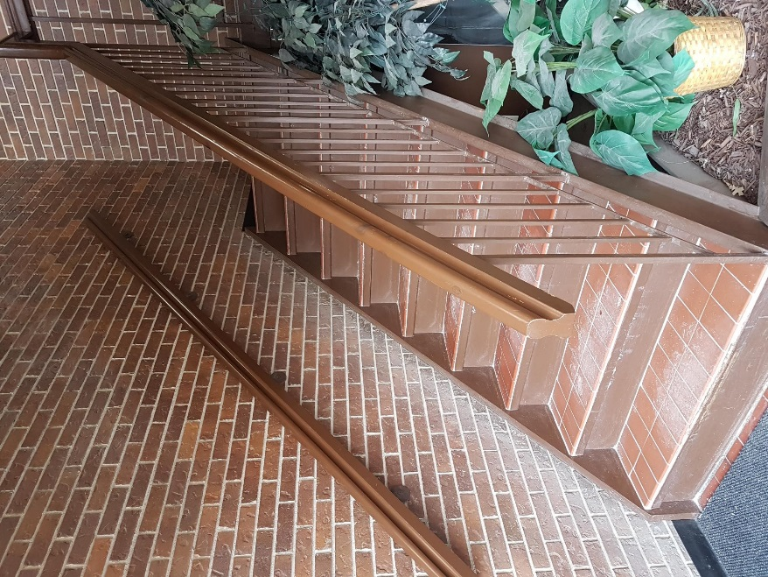
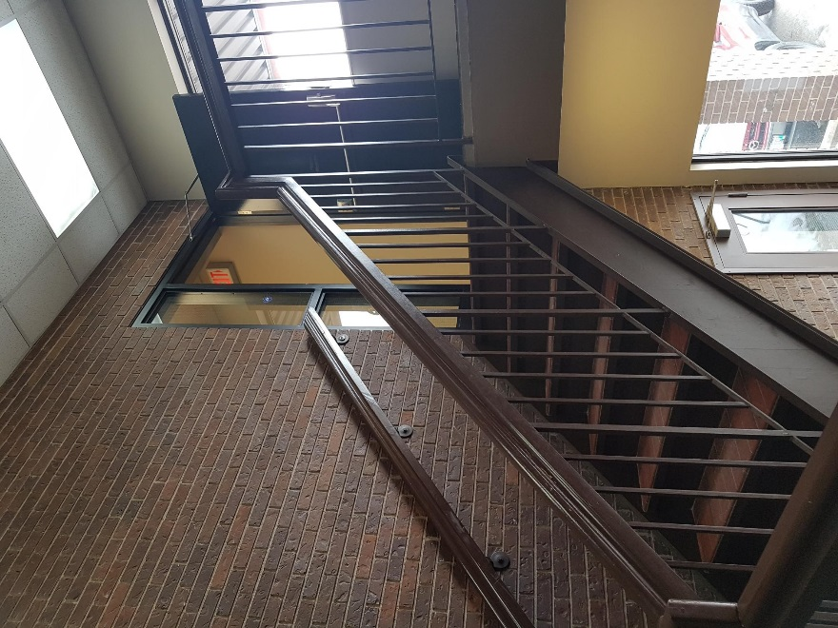
Go up the stairs to the second floor

At the top of the stairs, there will be an open door on your left hand side
When you look through that open doorway, you’ll see this

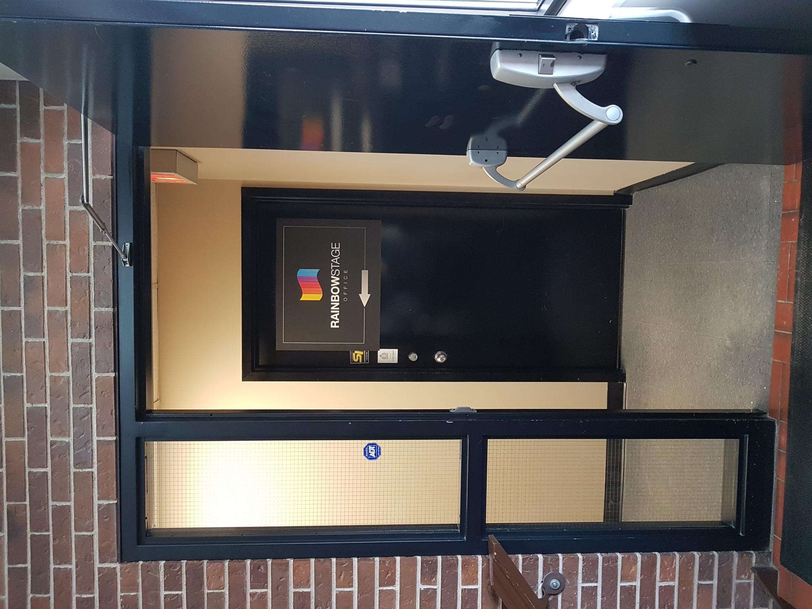
Walk through the open doorway and walk down this hallway
At the end of the hallway, you will see our office door
Open the door, you’re welcome to come inside
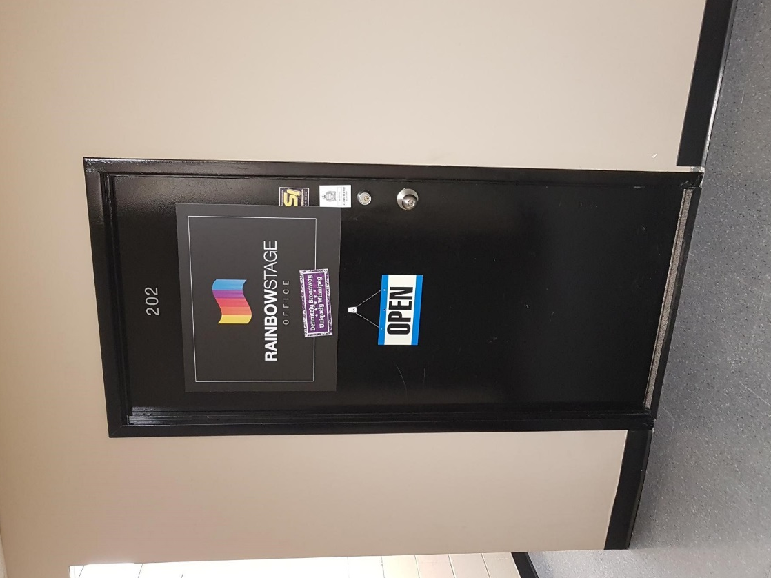
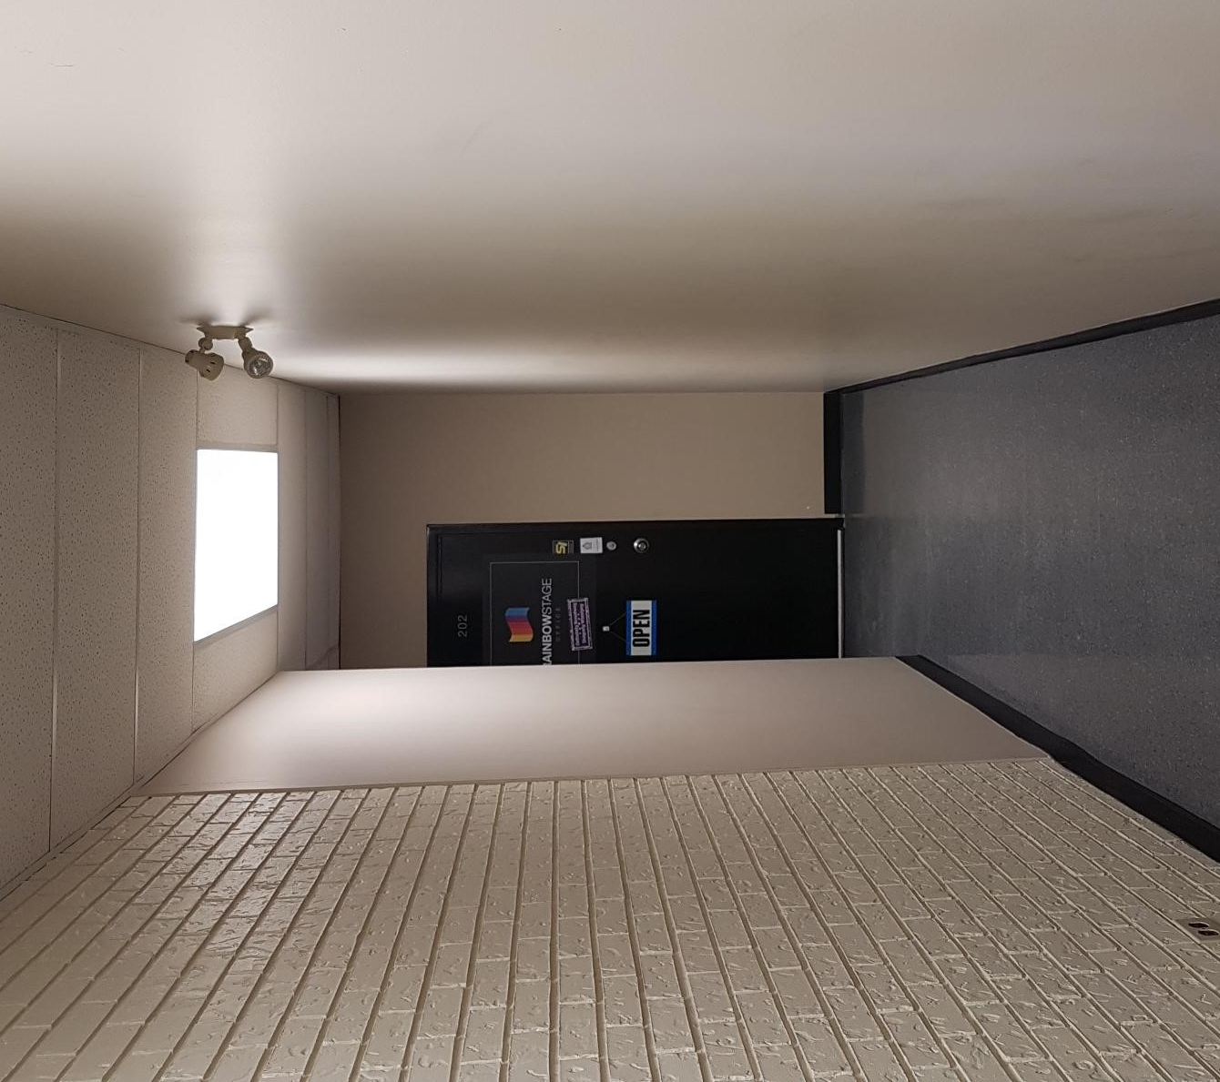
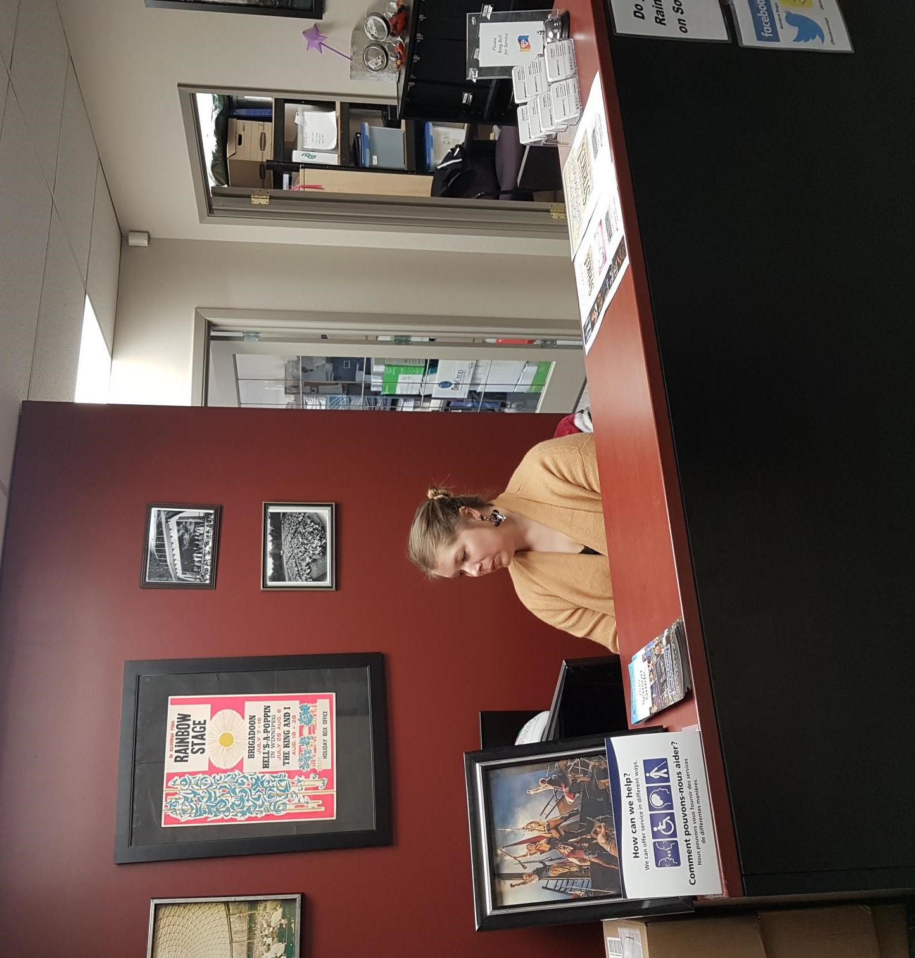
When you open the door, you’ll see one of our staff members sitting at the desk

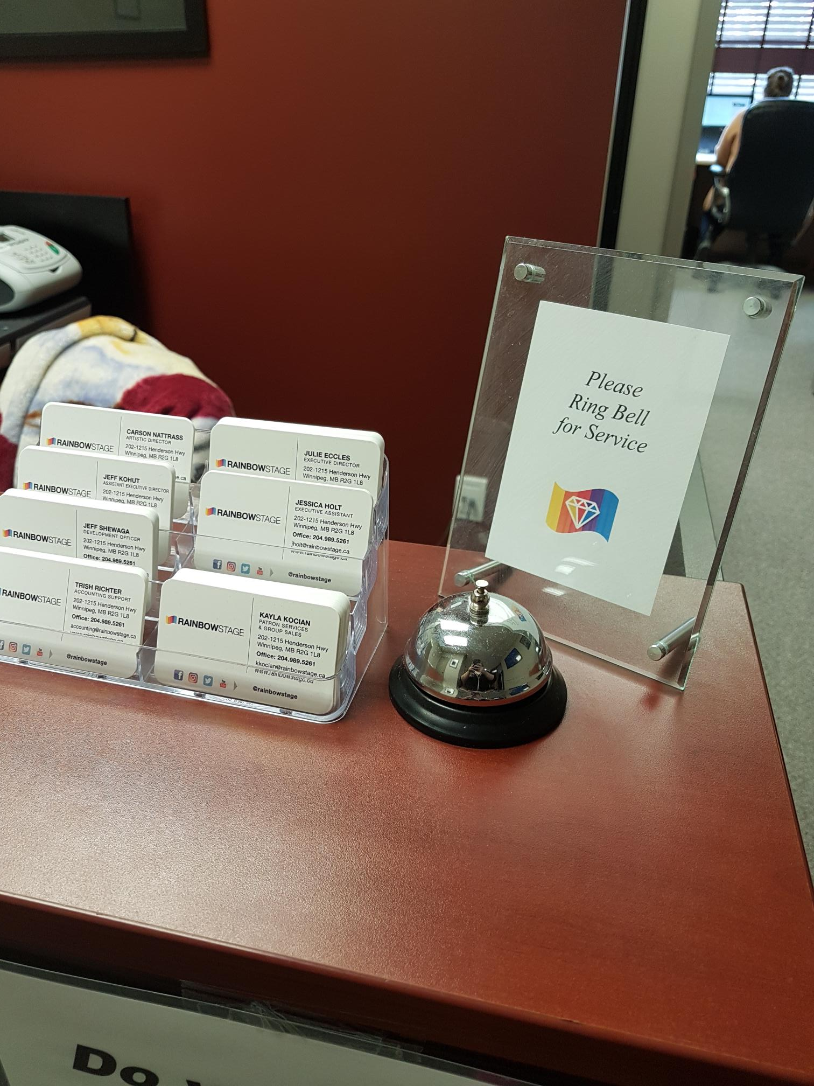

If no one is sitting at the desk,
ring this bell

To purchase tickets, the staff member will ask you the following questions:

- Your full name

- Your telephone number

- They will ask you to provide an address if you choose to pay with credit card. This must be the address on file with your credit card bill

- What show and what date you’d like to attend?

- Do you require wheelchair accessible seating?

- What price range would you like to purchase?

- Credit Card information
  - A VISA or MasterCard number
  - The card’s expiry date
  - CVV (the CVV are the 3 small numbers located on the back of the card above your signature line.
Once the agent puts the payment into our ticketing system, they are no longer able to see your personal payment information.

- The staff member will then print out your tickets and give them to you to take with you.

Purchasing Tickets In Person at Rainbow Stage
Inside Kildonan Park

The Rainbow Stage Box Office inside Kildonan Park is open May through August.
Please call 204-989-0888 or visit www.rainbowstage.ca/box-office-hours/ to confirm what hours they are open.
Once you arrive at Rainbow Stage inside Kildonan Park, you may park in the parking lot or on the main road that you drove on to get there (McKay Drive)
Please look for any NO PARKING or NO STOPPING signs before leaving your vehicle.

The Box Office is located at the front entry doors into the theatre
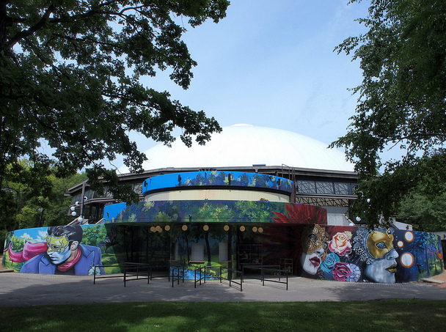
The person assisting you will require the following information from you when purchasing tickets.

- Your full name

- Your telephone number

- They will ask you to provide an address if you choose to pay with credit card. This must be the address on file with your credit card bill.

- What show and what date you’d like to attend?

- Do you require wheelchair accessible seating?

- What price range would you like to purchase?

- You will have the option to pay with cash, debit or credit card.

- Credit Card information
  - A VISA or MasterCard number
  - The card’s expiry date
  - CVV (the CVV are the 3 small numbers located on the back of the card above your signature line.
Once the agent puts the payment into our ticketing system, they are no longer able to see your personal payment information.

- The box office agent will print your tickets and give them to you.

