VISUAL STORY GUIDE:
Purchasing Tickets Online
to attend a
Rainbow Stage Summer Production

Table of Contents

Getting to the Rainbow Stage Website……………………………………………………………………………………….. 3
Rainbow Stage Ticket Buying Page …………………………………………………………………………………………….. 5
Creating Your Personal Account …………………………………………………………………………………………………. 6
Browsing Anonymously ……………………………………………………………………………………………………………….8
Forgot My Password ……………………………………………………………………………………………………………………10
You are now logged into your Account ……………………………………………………………………………………….. 11
Find your show, purchase your tickets ………………………………………………………………………………………… 13
Selecting your seats …………………………………………………………………………………………………………….……… 15
Paying for tickets in your cart ……………………………………………………………………………………………….…….. 18
Introduction

Welcome to Rainbow Stage’s visual story guide to purchasing tickets after creating an online account. This guide is designed to make the process easier for first time buyers, care workers of patrons who may need assistance with the process, or patrons who are unfamiliar or are less comfortable with the buying process.

In this guide you will find visual representation as well as detailed descriptions of the process of creating an online account and buying tickets online after creating that account.

Rainbow Stage welcomes patrons of every kind. We are excited to have you attend our productions and we hope you find this guide helpful when making your purchase.

If you have any questions, concerns or suggestions, our box office staff will be more than happy to assist you. 204-989-0888
This visual guide uses images.

The images may not accurately represent the current shows being offered at
Rainbow Stage.

The instructions remain the same.

Getting to the Rainbow Stage Website

Open your internet browser
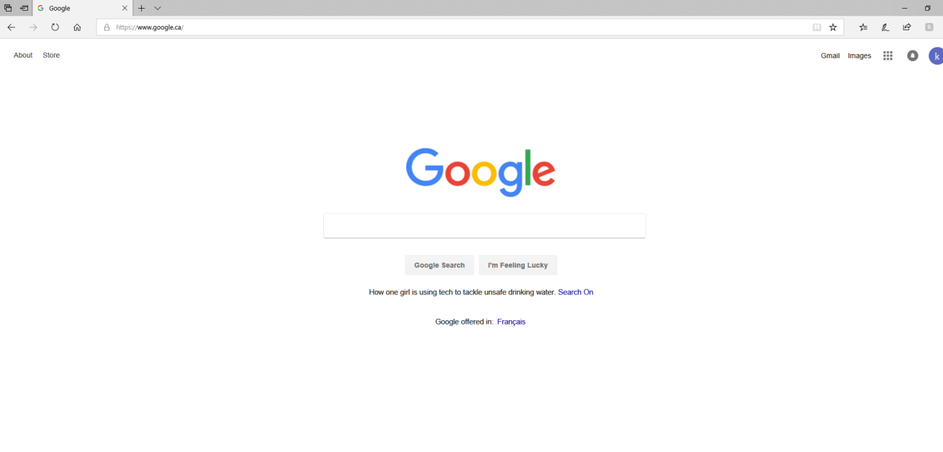
- The kind of browser you use does not matter
- Every home screen may look a little different

In your navigation bar (this is the area circled below), type www.rainbowstage.ca, then hit enter on your keyboard.

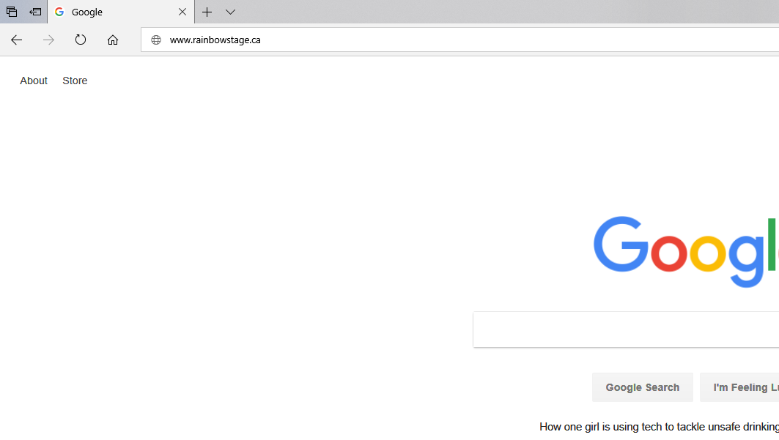
This is the next page your screen will show you. This is the Rainbow Stage website HOME page in the photo below.

The image at the top of the screen (shown here as “Our New Location will be 202-1215 Henderson Hwy) will rotate through other images as well. These images are changed frequently to announce new things.

The black bar across the screen with the red buttons labeled “BUY TICKETS” and “DONATE” will remain still and does not change.

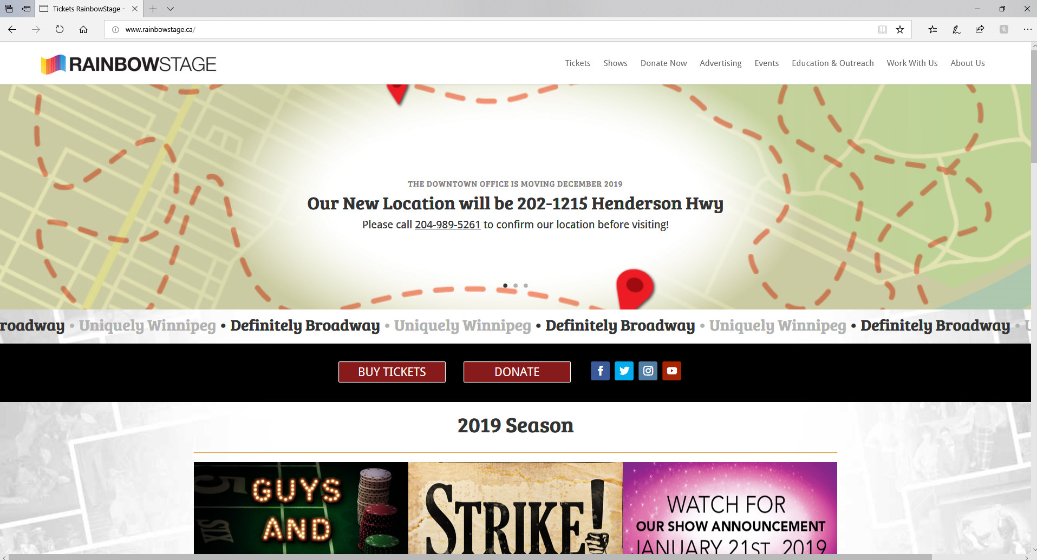

Click on the red button labeled “BUY TICKETS”
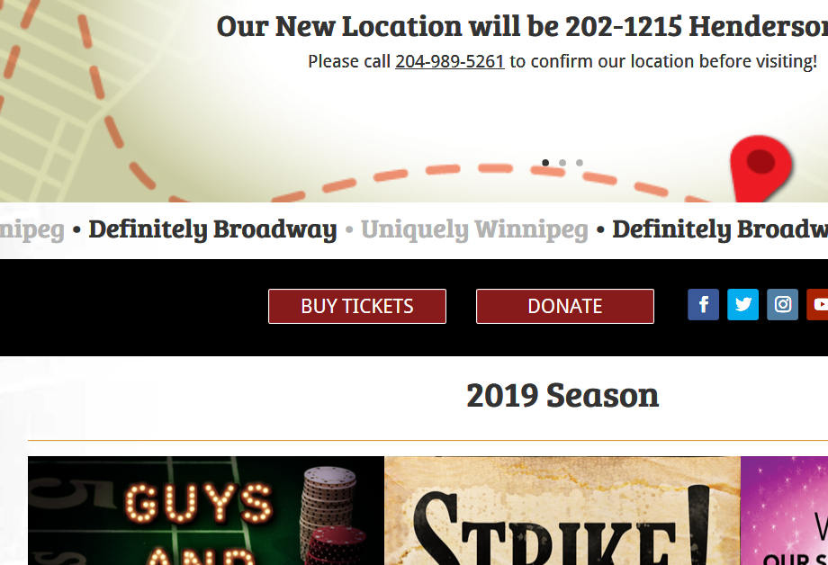
Your screen will change and finish like this. This is the TICKET BUYING PAGE
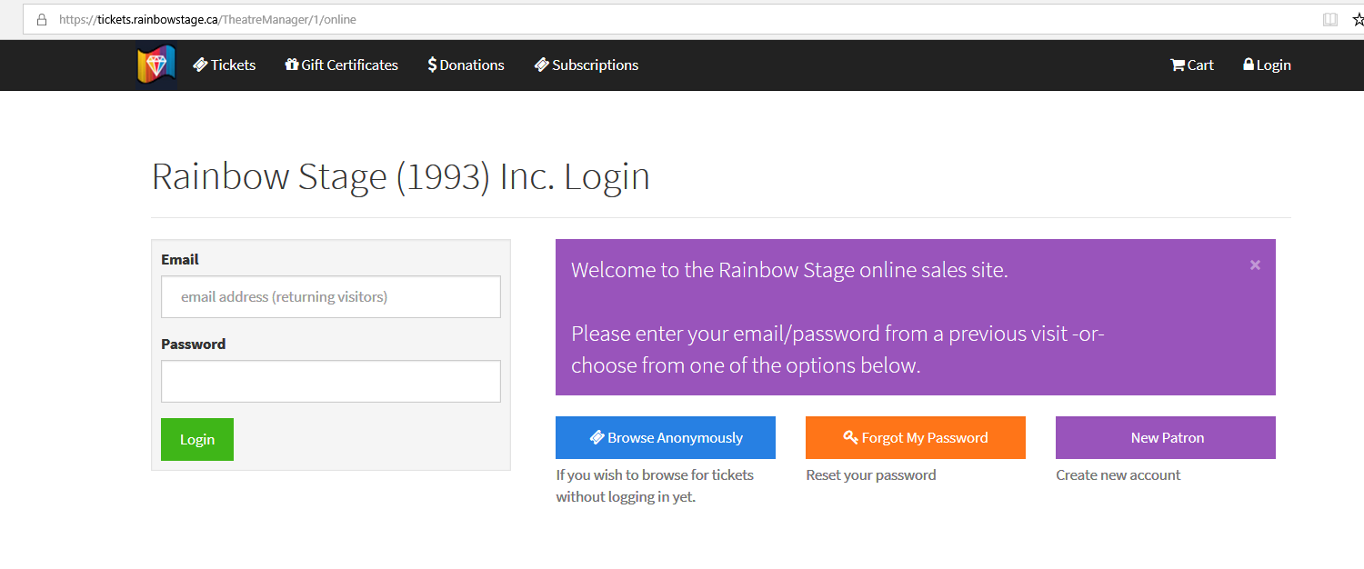

New Patron:
If you have never purchased tickets for Rainbow Stage (online, over the phone or in person) then you will click here to set yourself up with an account.

Click on this button

For details on the other options, go to these pages:
Browse Anonymously – go to page
Forgot My Password – go to page

Creating Your Personal Account
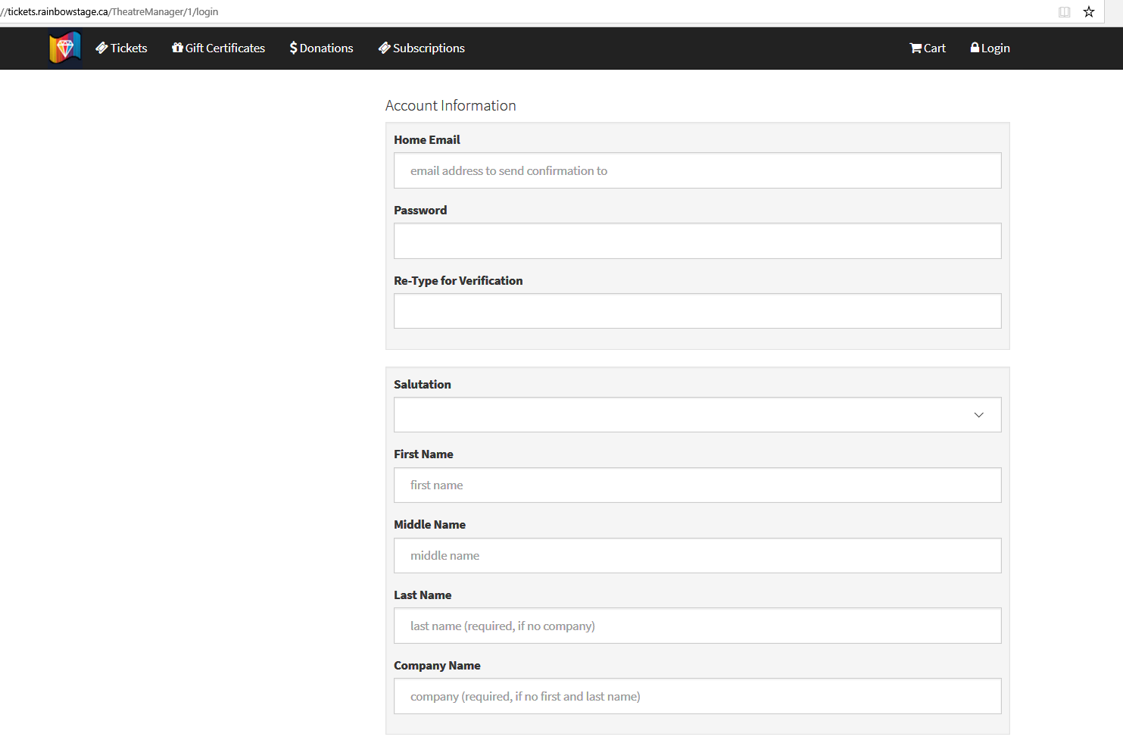
This will be the next screen you see
Now you can start typing in each box.
Use your personal information to complete the online form.
Scroll down to view more of the online form.

At the bottom of the form, you will see the option to eneter a CAA membership number if you have one.

Rainbow Stage offers a CAA discount on some tickets.

If you do not have a CAA membership, leave this blank.

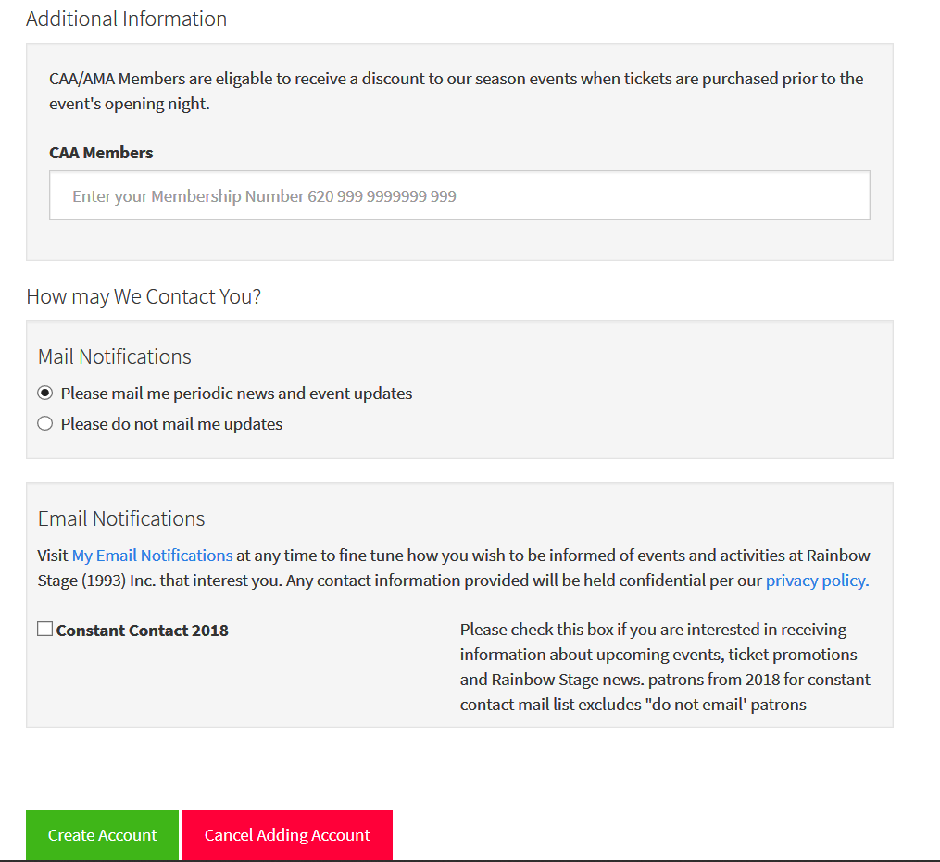
You can also select whether or not you would like to receive updates from Rainbow Stage via mail and email.
Click the green button labeled Create Account, when finished

Browsing Anonymously
Browse Anonymously:
If you want to see what is available but not quite ready to purchase, click here.
Note: If you decide to purchase what you see while “Browsing Anonymously”, you will be redirected back to this page and required to log in.
If you need to create a new account, you can do so at this time.
The next screen you will see is the list of all performances to choose from.
Just scroll through the list until you find the show and date that you’d like, then click BUY
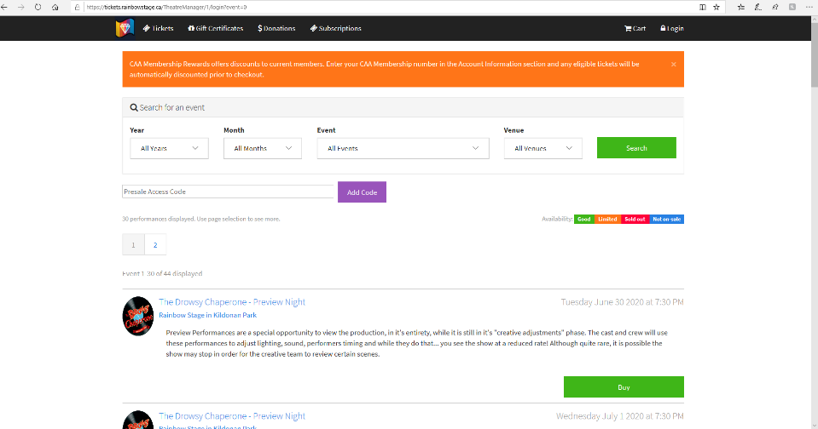

Forgot My Password
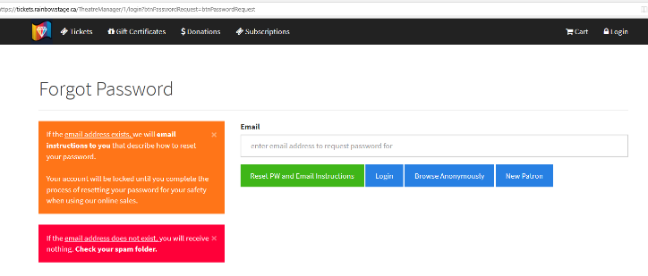
Forgot My Password:
Click here if you know you have an existing account but you don’t remember your password.
The system will ask you to enter your email address and will send you a link to select a new password. This can take a few minutes to arrive in your inbox.
You are now logged into your account

This is the next screen you will see. This is your HOME PAGE
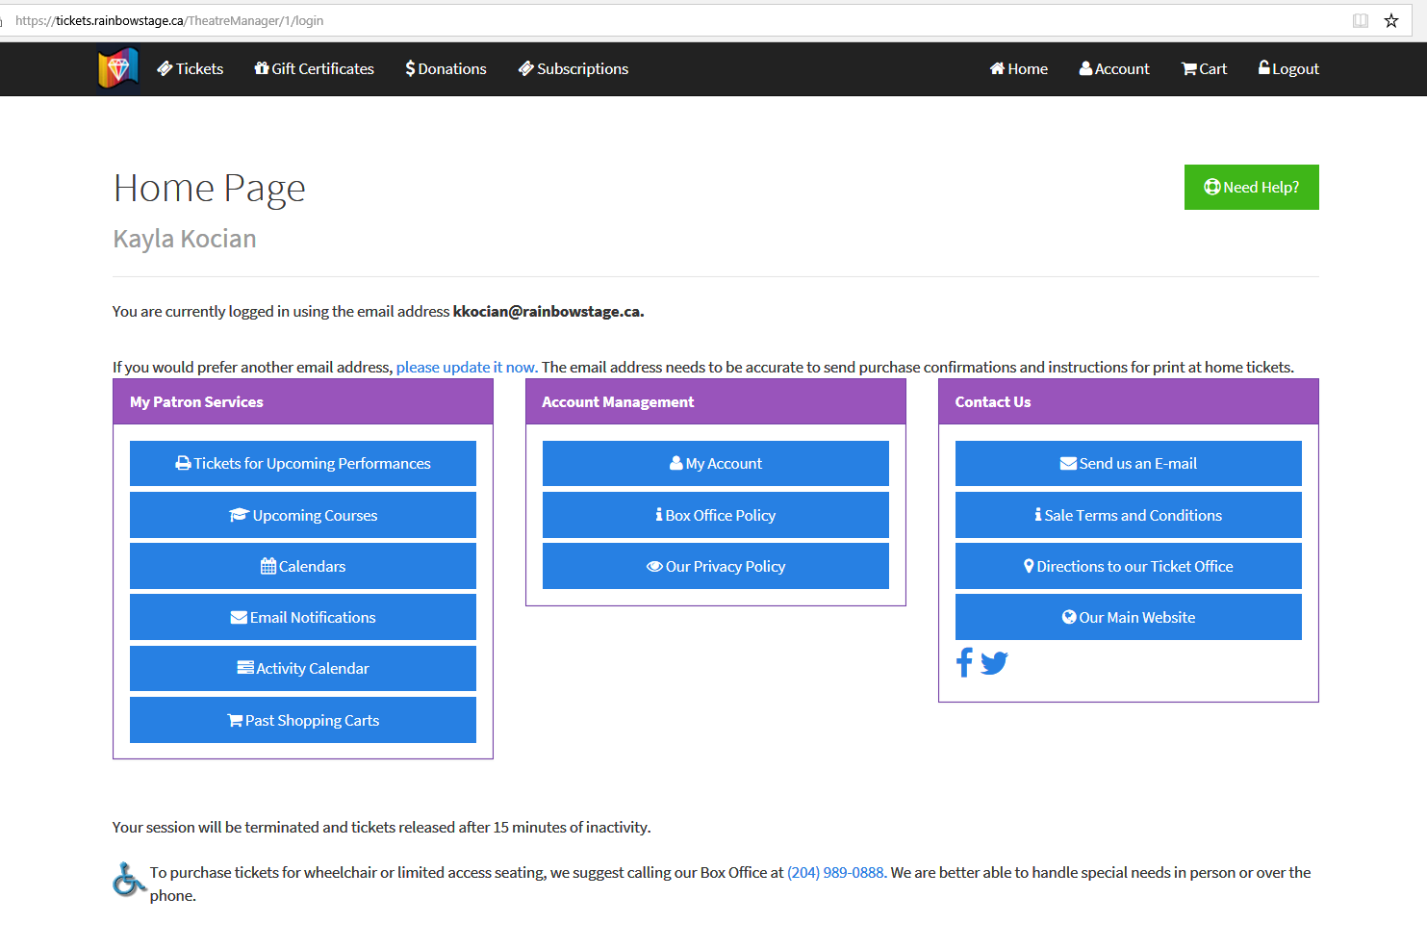
This will say your email
This will say your name
You can buy new tickets – click on the button near the top of your screen

You can view tickets you’ve already paid for – click on the button

You can print tickets you’ve already paid for – click on the button

You can change your personal information -

You can contact box office staff by email -

Click on the icon at the top of your page, your screen will change to this page.
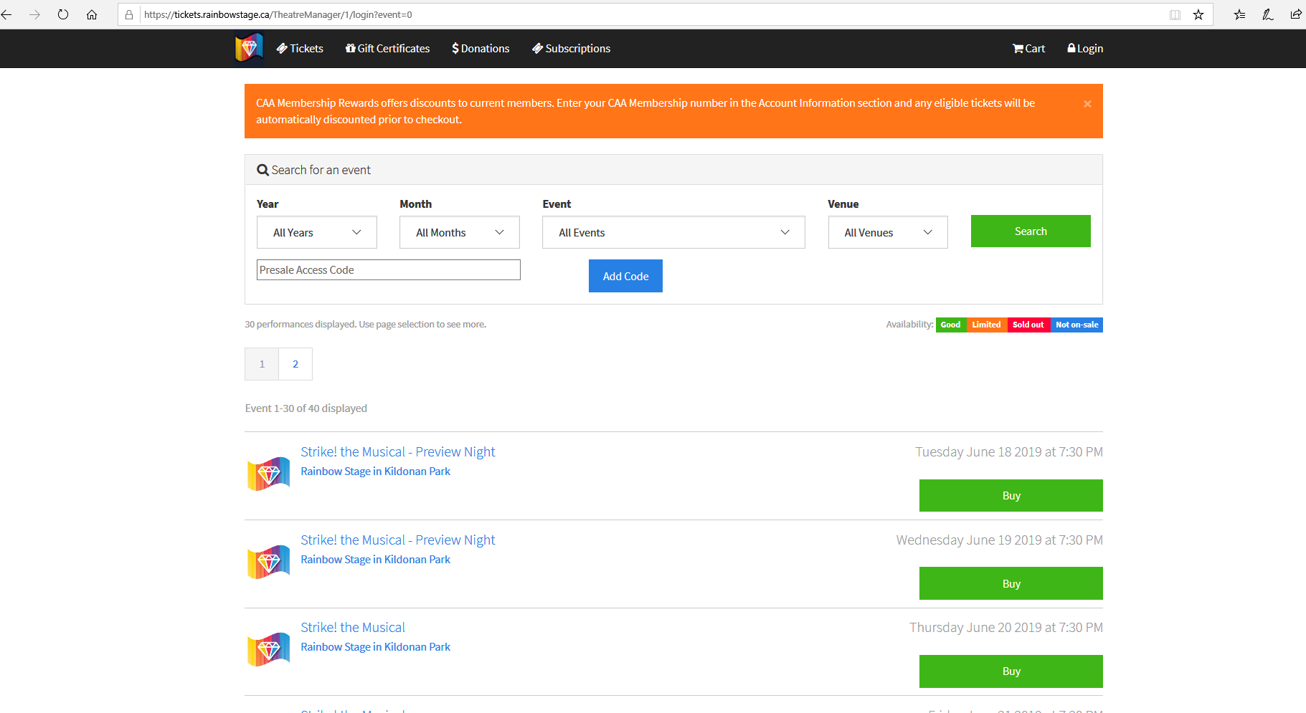
As you scroll through the page, you can see a list of show titles and the date and time that they are playing.

When the buttons labled “BUY” on the right side of the screen are GREEN, this means there are a lot of tickets left.

When the buttons labled “BUY” on the right side of the screen are ORANGE, this means there are some, or few tickets left.

When the buttons labled “BUY” on the right side of the screen are RED, this means there are no tickets left.

Once you have found the show you’d like to see, double check the date and time, click the BUY button in the column on the right.

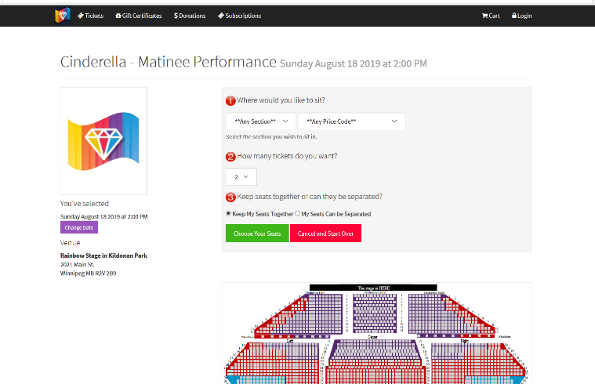
After clicking that button, your screen will change to this:

Click here to select how many seats you would like to purchase

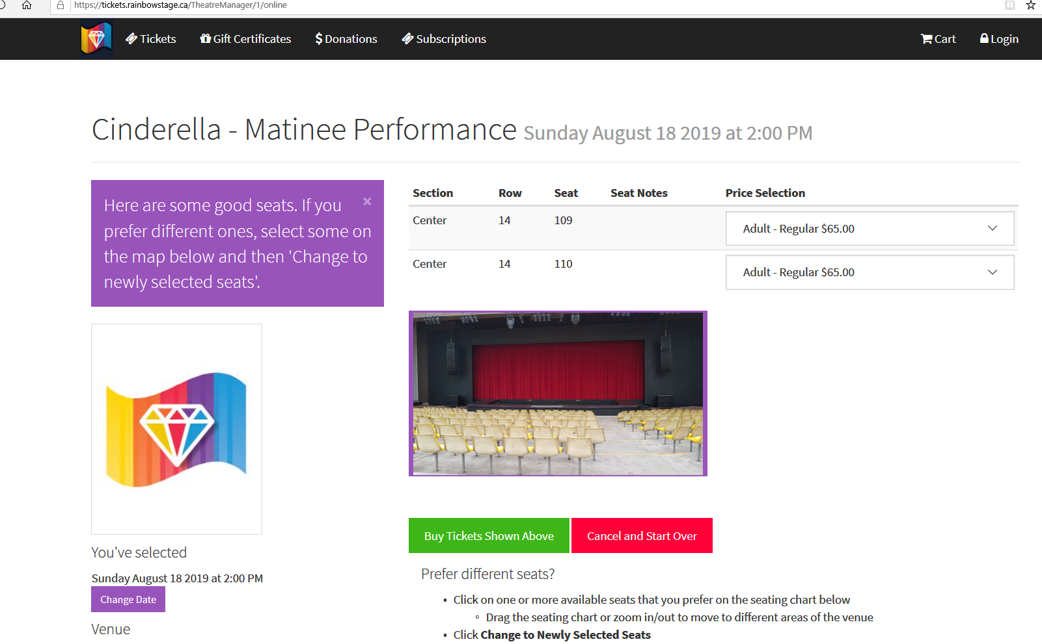
For the best seats available right now, click here
The screen will change to this

You can see: (from top to bottom)

- The show title, date and time that you have selected
- The best seats that our ticket system has selected for you
To the right of the seat location, there is a drop down menu where Child Pricing can be selected if it’s available in that section. (Child Prices are only available sections where adults are $55 or $39)
- A picture that gives you an idea of what the stage will look like when you are sitting in that seat
- “Buy Tickets Shown Above” – click here if you like these seats and want to go ahead with buying them
- “Cancel and Start Over” – click here if you would like to start from the very beginning
- “Change Date” – this is on the left side. Click here if you want to try a different show or date.

If you like the seats the computer has suggested for you, click

See the next page for more options.

If you want different seats…
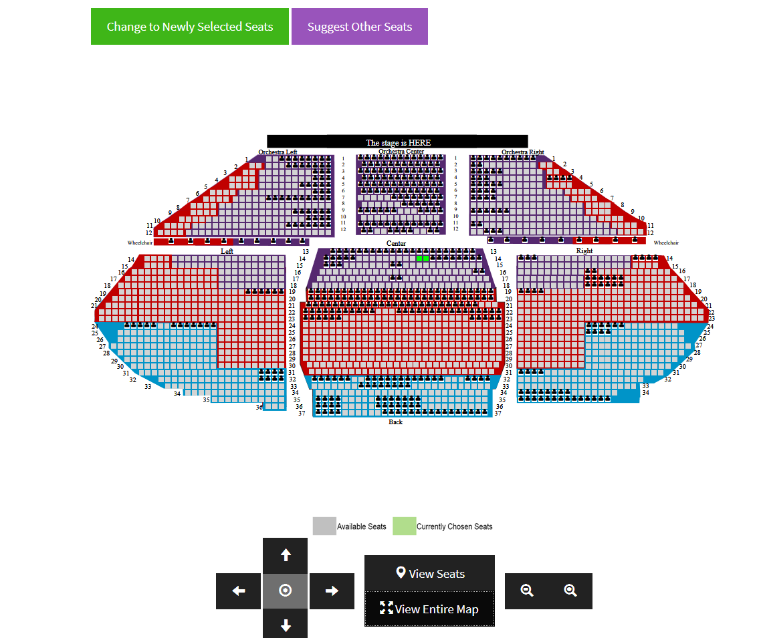
Scroll down the screen, you will see this:
This is the seating map of the theatre.
The Green squares on the map will show you where the seats (that are listed at the top of your screen) are located.
The Grey squares show you seats that are available to buy.
The squares with black inside them are seats that are sold to other people. (if you look closely, you can see the black images look like tiny people)
If you see grey squares (seats) that you like better than your green ones, click on them, then click the big green button labelled “Change to Newly Selected Seats”
If you select the Purple Button labelled “Suggest Other Seats”, the computer system will select new seats for you.
There is a timer started once you have reached this page. You are given 15 minutes to complete your purchase.
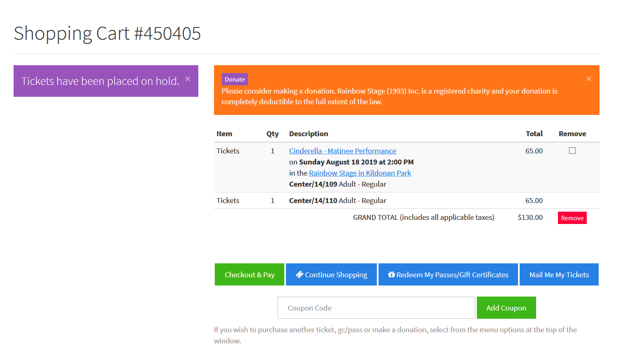
Next, you will see this page
You can choose:
Checkout & Pay – this brings you to the screen that asks for your personal payment information
Continue Shopping – is there another date or show you’d like to buy at the same time? You can add it by clicking here and going through this process a second time. All tickets will later show up together on this page.
Redeem My Passes/Gift Certificates – Did someone buy you a Rainbow Stage Gift Certificate as a gift? You can use it for payment here.
Mail Me My Tickets – click here if you want your tickets mailed to you.
Add Coupon – Sometimes special discounts are advertised and people use special passwords to unlock them.
If there are too many tickets in your account and you don’t want to buy them all, click the box under the “Remove” column, next to the tickets you DON’T want, then click the RED Remove button.
If you would like to make a donation to Rainbow Stage with your purchase, please click on the DONATE button found inside the big orange box at the top.

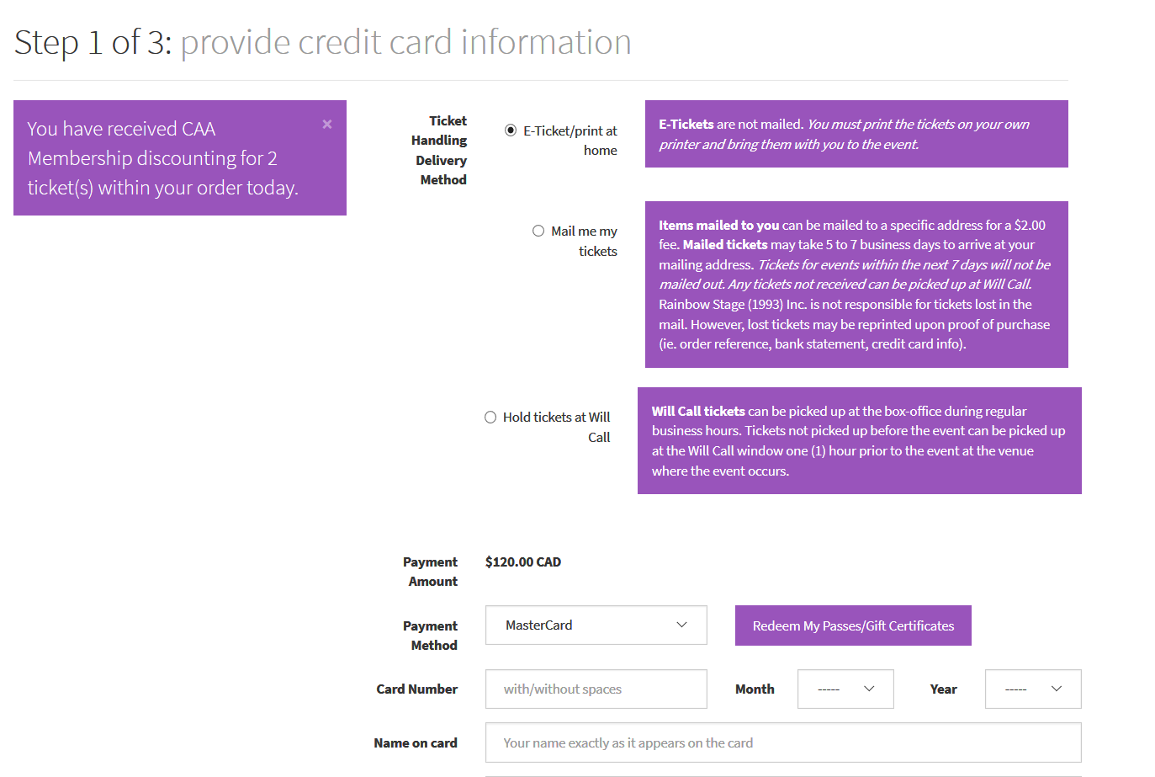
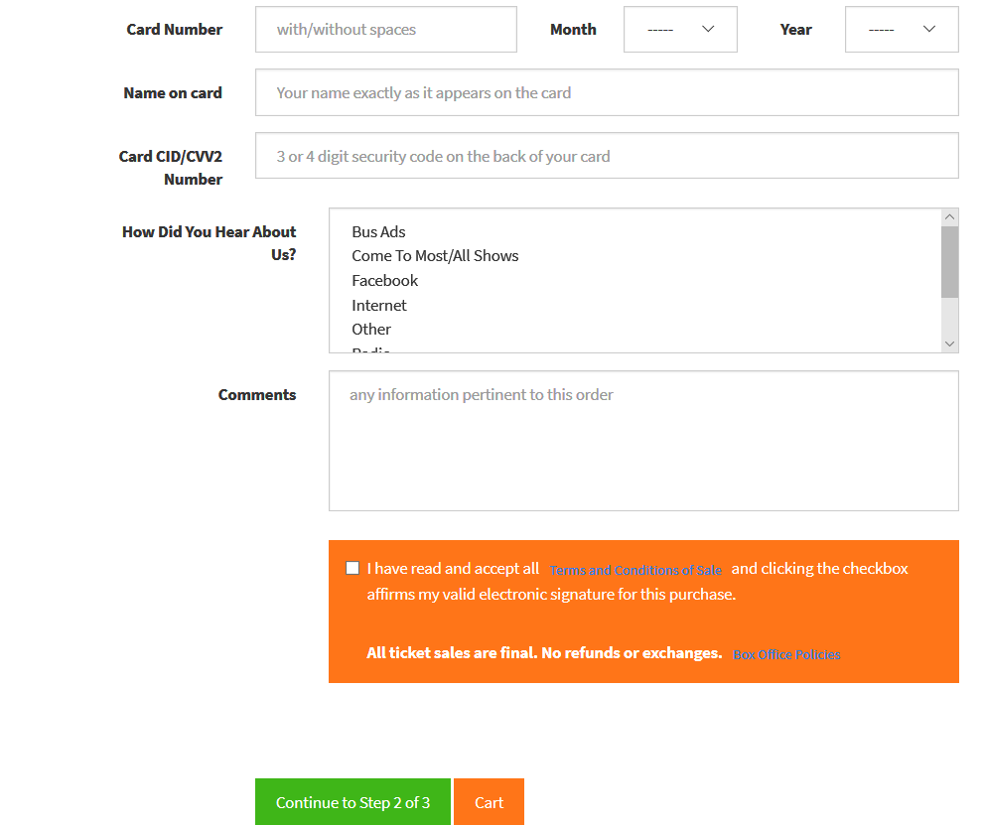
After clicking Checkout & Pay
This screen will ask you for personal payment information such as:
- How would you like us to deliver your tickets?
- What kind of credit card are you using?
- All the credit card information
Rainbow Stage uses a ticketing system that is very secure and no information that you enter here is shared with any outside sources.
Only one Rainbow Stage employee has the ability to see the information that you enter here.
If you have any questions about this process, you may contact Kayla Kocian at kkocian@rainbowstage.ca or 204-989-5261 x102.

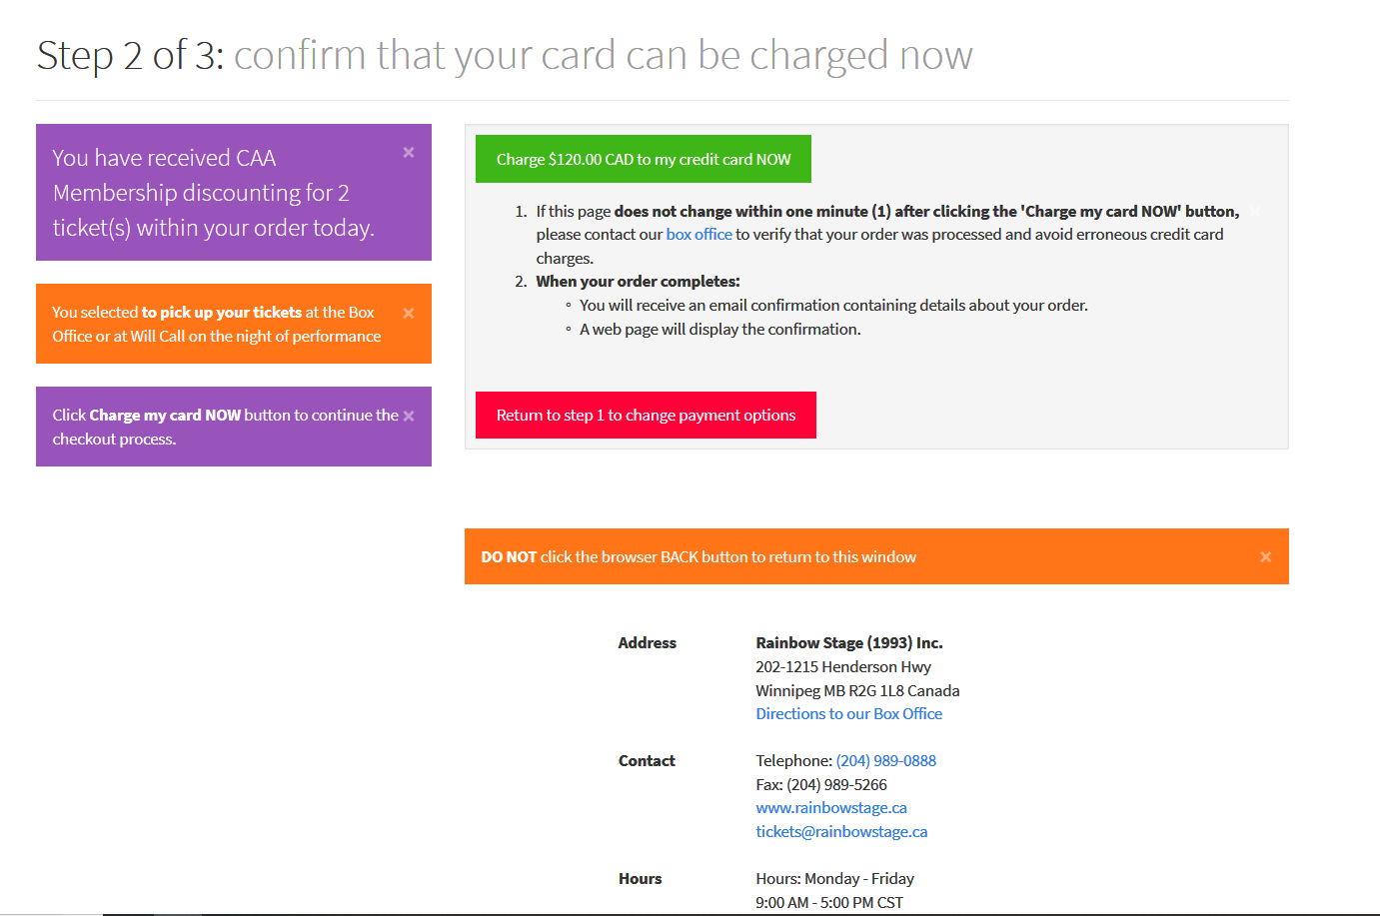
This is the next screen you will see after clicking Continue to Step 2 of 3 (green button)

Review the information and click the green button that verifies that you are ready to charge the ticket amount to your credit card

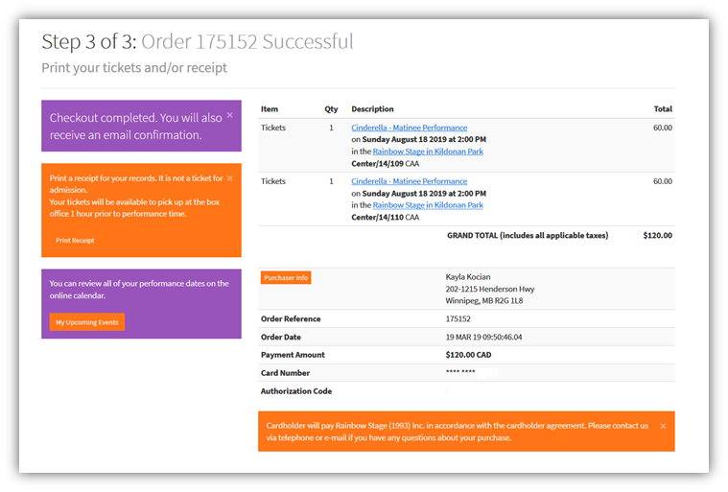
This is the next screen you will see

This shows you that your order went through successfully

Soon after, you will receive an email confirmation of the purchase.

This email will only include a PDF file of your tickets if you selected to receive your tickets via email.

No matter what delivery method you choose, you can always view and print your tickets from your Account Home Page, listed on page 8 of this visual guide.

