VISUAL STORY GUIDE:
Public Transportation
&
Tour Bus Navigation

Table of Contents

Winnipeg Transit …………………………………………………………………………. 3
Taxi Service ……………………………………………………………………………….…. 8
Handi-Transit ……………………………………………………………………………….. 9
Tour Bus Operators ………………………………………………………………………. 10

Introduction

Welcome to Rainbow Stage’s visual story guide: Public Transportation & Tour Bus Navigation.

This guide is designed to make the process easier for first time visitors, care workers of patrons who may need assistance with the journey, or patrons who are unfamiliar or are less comfortable with the surrounding area.

In this guide you will find visual representation as well as detailed descriptions of the surrounding area (Kildonan Park).

Rainbow Stage welcomes patrons of every kind. We are excited to have you attend our productions and we hope you find this guide helpful when visiting.

If you have any questions, concerns or suggestions, our box office staff will be more than happy to assist you. 204-989-0888

Winnipeg Transit

The best way to plan a trip to Rainbow Stage using Winnipeg Transit is to visit

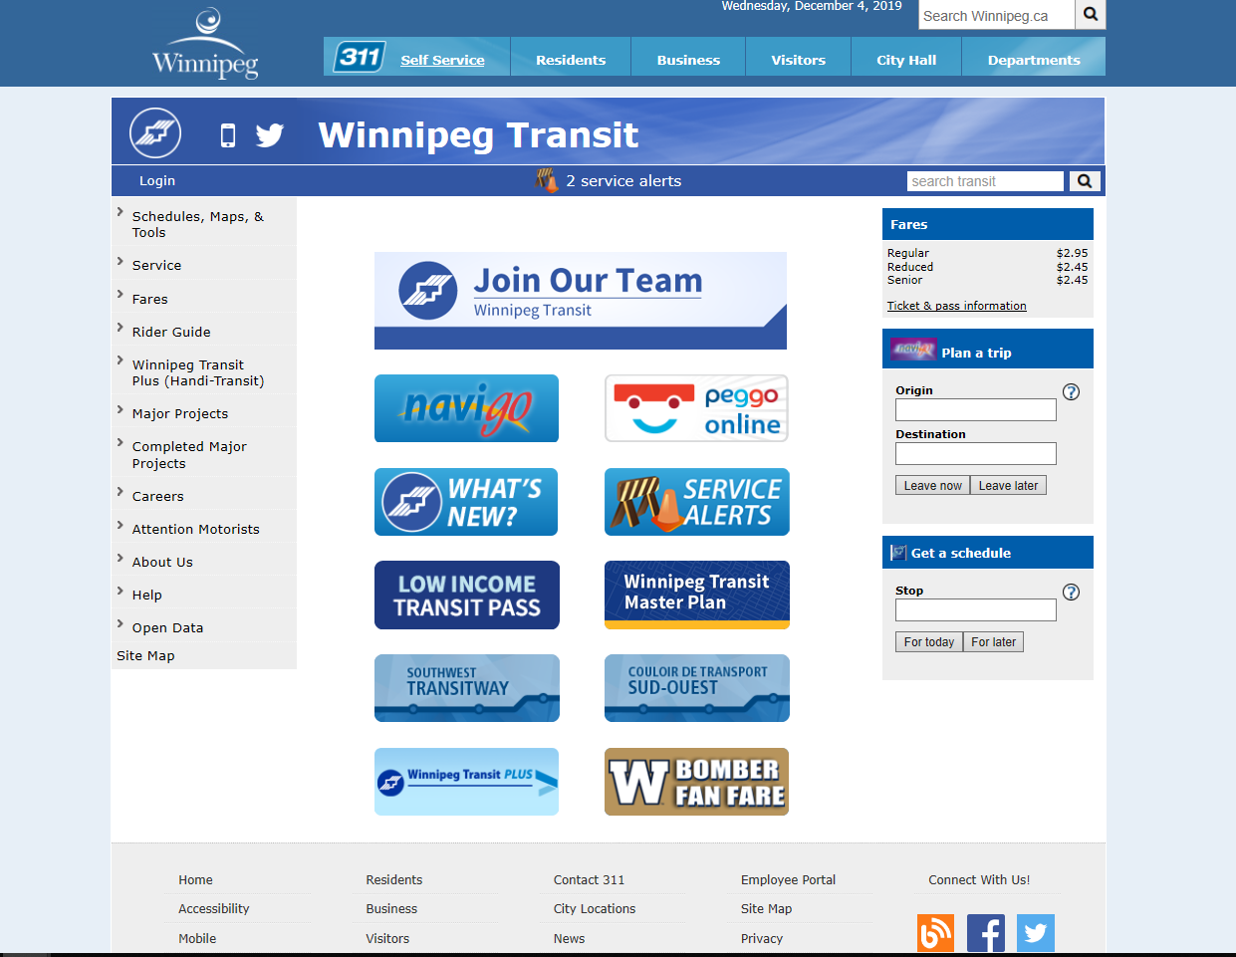
www.winnipegtransit.com

From this page, click HERE (Navigo)

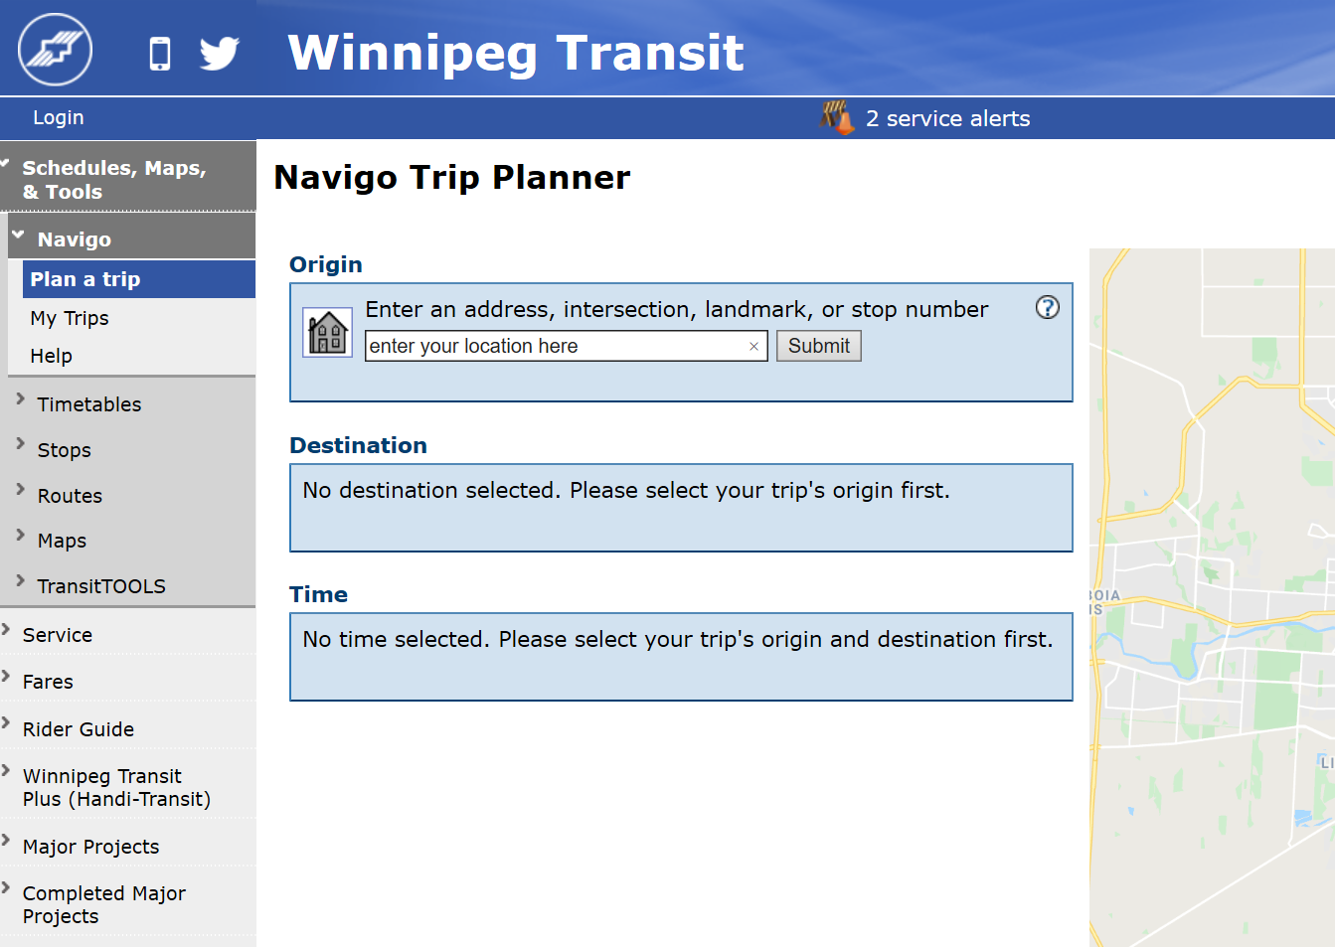
This is the next screen you will see

You will enter your starting location into this box and click

Once you have chosen your starting location, you’ll be required to enter your destination
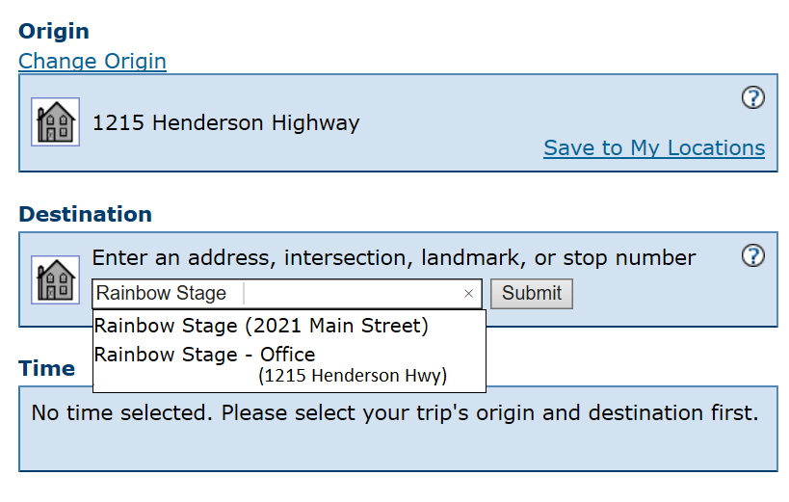

This is an example. You will enter the correct location that you begin from.

Type “Rainbow Stage” into the Destination box here

You’ll be given 2 locations to choose from:

Rainbow Stage (2021 Main Street) – this is the location inside Kildonan Park. This is where you visit to attend the production.
Rainbow Stage – Office (1215 Henderson Hwy) – this is the location of the Administrative Offices. This is where you can buy tickets in person between September and May.

Make your selection and click

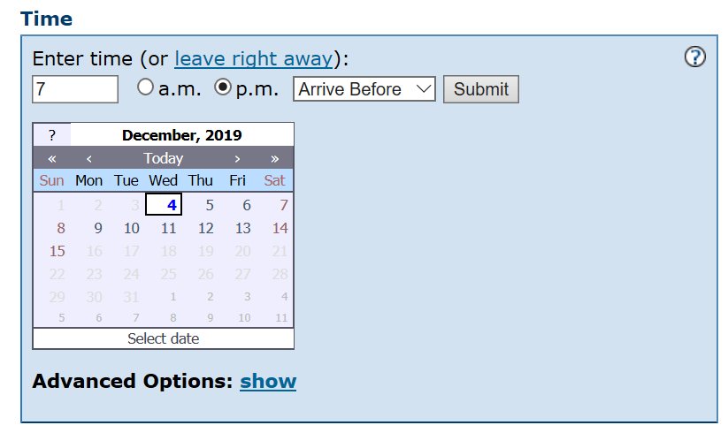
Next, you’ll be required to select a time
This calendar will only display a 12 day period. You can not see the bus schedules for any dates too far in the future.
For best results, use a similar setting to what is shown here.

To be sure you arrive with enough time to walk from the bus stop to the theatre inside Kildonan Park, we suggest setting your arrival time to, at least, 30 minutes prior to show time.

Evening Shows begin at 7:30pm
Matinee Shows begin at 2:00pm

You can change the “Arrive Before” time to whatever you feel is best for you.
Make your selection and click

The bus stop numbers located in front of Kildonan Park are:

Southbound bus – 30024
Northbound bus – 30023

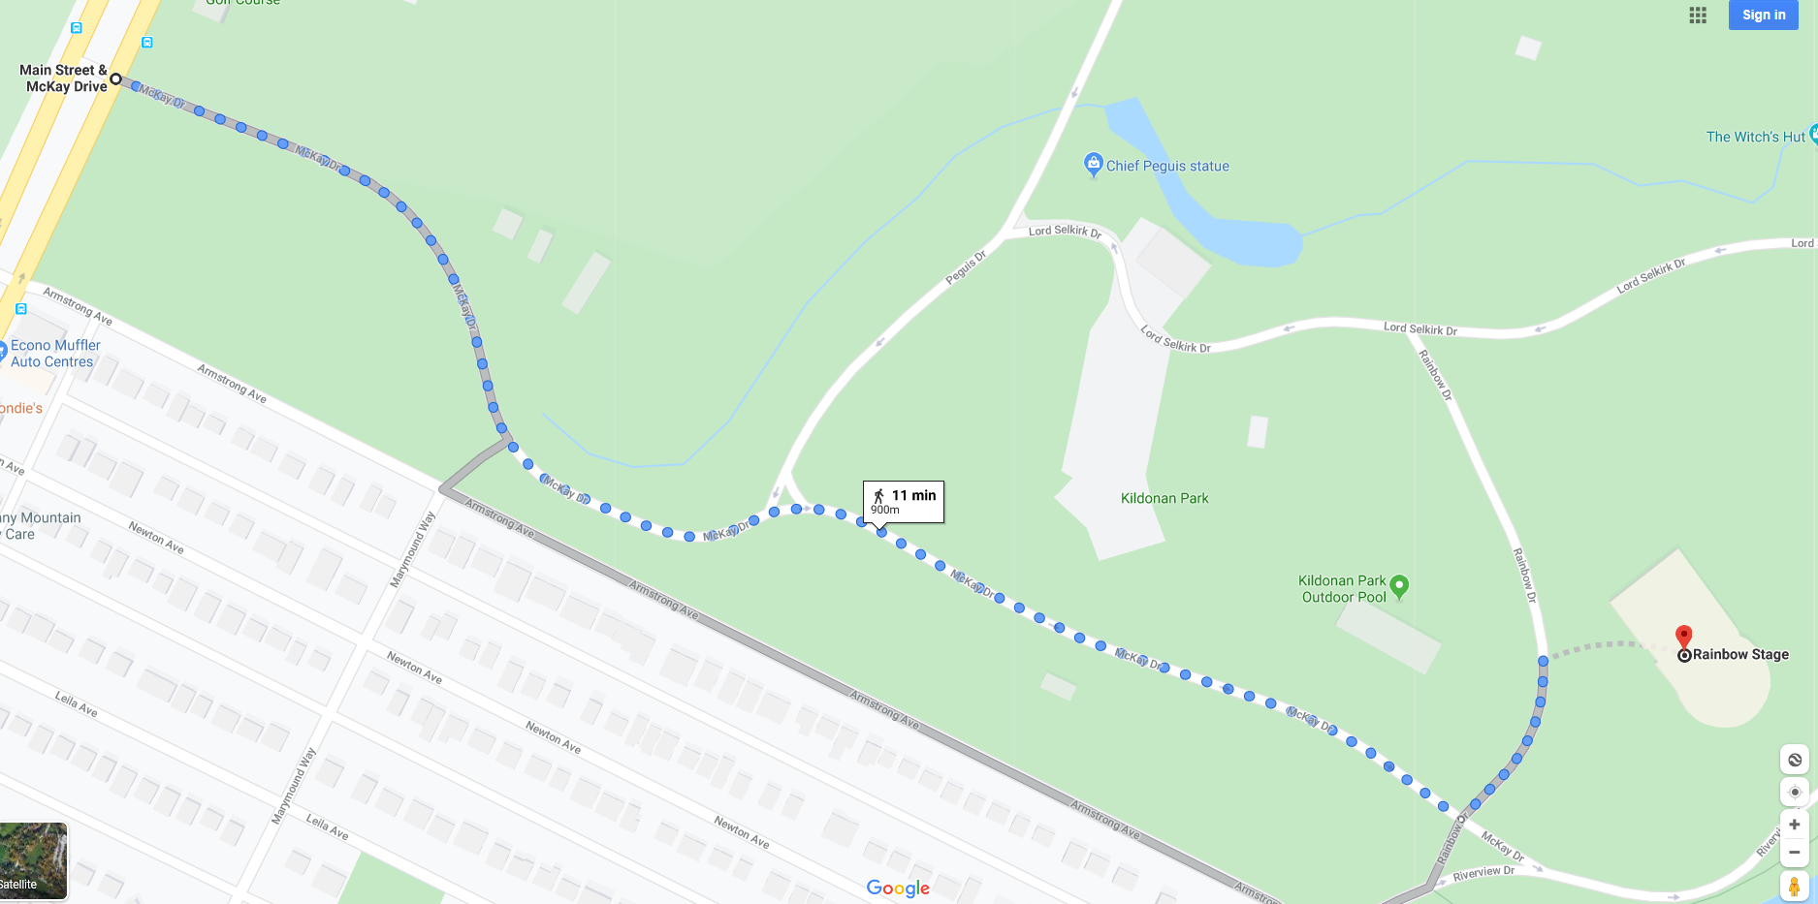
After arriving at the bus stop, you will need to walk to the theatre inside Kildonan Park.
These blue symbols represent the 2 bus stop options

The walk takes about 11 minutes for the average person.

Please allow yourself more time if necessary. Dress appropriate for weather conditions. This walk is outdoors and is uncovered.

Winnipeg Taxi Services

You can call any of the following taxi services for transportation to Rainbow Stage.

Duffy’s Taxi 204-925-0101
Unicity Taxi Ltd 204-925-3131
Spring Taxi 204-774-8294

Allow yourself extra time when traveling by taxi.

Taxi services can often take longer to arrive to pick you up and will not always take the most direct/quickest route to your destination.

Our address:

Rainbow Stage Theatre – where you will attend your show
2021 Main Street, Inside Kildonan Park

The driver will enter the park and drop you off right in front of the theatre.
Please ask your driver to remain on the Main Park Road.
Do NOT drive on the sidewalks inside the park.

Rainbow Stage Administration Offices – where you can buy tickets in person
between September and May
1215 Henderson Hwy

The driver will drop you off in front of the office building.
You will find Rainbow Stage on the second floor.
Click here for details on how to find our administration office.

Winnipeg Handi-Transit Services

The Winnipeg Handi-Transit System is available to approved applicants.

For information on the program, please visit
https://winnipegtransit.com/en/winnipeg-transit-plus-handi-transit/

If you are arriving by Handi-Transit:
- The driver will enter the park from one of the 2 public entrances
Click here for a map
- The driver may drop you off at the front of the theatre or at the drop off point on the south side of the theatre. See GREEN circles on image below.
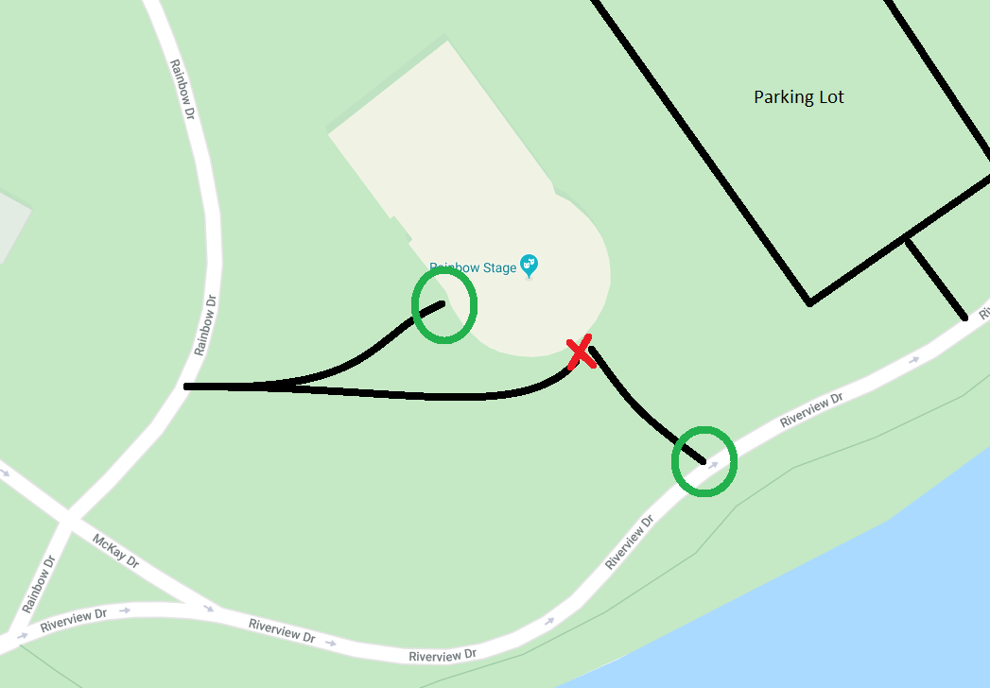
This is the Drop Off Zone on the south side of the theatre.

This is a public sidewalk, and is often CROWDED. No vehicles are permitted. This is NOT a drop off zone

This is the sidewalk leading to the Front doors of the theatre – where all patrons are required to enter

- If you can, please ask the driver NOT to drive on the sidewalks in front of the theatre. The RED X indicated on the image, is NOT a drop off zone.
- If you are dropped off at the south side drop off zone, you will be required to enter through the FRONT doors of the theatre. There is no access from any other door.
Tour Bus Operators

Rainbow Stage is a popular attraction for local and traveling tour groups.

Tour busses are welcome!

There is plenty of space in the parking lot provided to park tour busses or large vans.

Once arriving, proceed to the parking lot.

There, you will be greeted by security/parking staff. These attendants are employees of a third-party company, contracted by the City of Winnipeg.

The parking lot staff will guide you to the best place for your tour bus or large van.

