Greetings from Rainbow Stage’s
Artistic Director, Carson Nattrass

Each year, following Rainbow Stage’s magical season of musical theatre, we return for one more show-stopping number with our annual Encore Fundraising Gala.

Save the date!
2020 ENCORE FUNDRAISING GALA
September 26th, 2020
Fairmont Hotel

We welcome you to join us onstage for this thunderous “curtain call” through a prize donation and/or sponsorship.

Rainbow Stage remains the largest, longest-running open-air professional theatre in Canada. It is Canada’s leading not-for-profit charitable arts organization dedicated solely to musical theatre. Its “Manitoba First” value has stewarded the career of Manitoba artists to stages around the world, including Broadway.

Last year, ENCORE raised over $40,000.00 for our Education and Outreach programs, Professional Mentorship programs and more…allowing us to continue our investment in Manitoba talent through our School Awards and Student Scholarships Program, the Musical Theatre Conference for Students, Camp Rainbow, the Actor’s Intensive and our free community dance classes.

We sing and dance for prize donations!

We seek a plethora of items for both our Silent & Live Auctions and valuable Sponsorships.

Rainbow Stage sees over 40,000 patrons through our doors every summer and humbly engages them with one of the largest social media followings in the arts community. Contributing to Rainbow Stage’s 2020 Encore Fundraising Gala provides your business with an opportunity to be promoted and connected in a unique way to a passionate audience…all the while helping to ensure the future of world-class musical theatre in Manitoba.

Please find attached the outline of each of the different Sponsorships available! Thank you for your generous support and for investing in Manitoba’s future artists. We look forward to connecting with you. If you have any questions or require any additional information, please contact:

Jeff Shewaga at 204-989-5261 x103 and jshewaga@rainbowstage.ca or Jessica Holt at 204-989-5261 x101 and jholt@rainbowstage.ca

Yours,

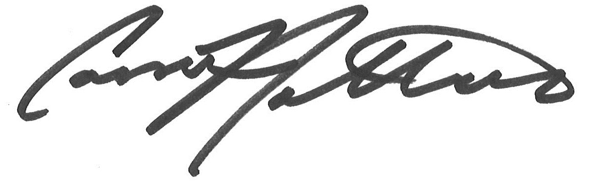
Carson Nattrass
Encore Sponsorship Opportunities

Major Sponsor/Dinner Sponsor - $10,000.00
• 2 tables of 8 at the event
• Prime placing of acknowledgement in the event program
• Acknowledgement in each of the 2021 show programs (2) full page ads (one for each show)
• Season tickets (flex) for 4 guests to the performance of each of the 2021 shows

Entertainment Sponsor - $7,200.00
• 2 tables of 8 at the event
• Acknowledgement in the event program
• Acknowledgement in each of the 2021 show programs (2) 1/2 page ads (one for each show)
• Season tickets (flex) for 4 guests to the performance of each of the 2021 shows

Wine Sponsor - $3,600.00 (sold)
• 1 table of 8 at the event
• Acknowledgement in the event program
• Acknowledgement in each of the 2021 show programs
• Season tickets (flex) for 2 guests to the performance of each of the 2021 shows

Hors d’ouvres Sponsor - $3,600.00
• 1 table for 8 at the event
• Acknowledgement in the event program
• Acknowledgement in each of the 2021 show programs
• Season tickets (flex) for 2 guests to the performance of each of the 2021 shows

Dessert Sponsor - $3,600.00
• 1 table of 8 at the event
• Acknowledgement in the event program
• Acknowledgement in each of the 2021 show programs
• Season tickets (flex) for 2 guests to the performance of each of the 2021 shows

Champagne Sponsor - $3,600.00
• 1 table of 8 at the event
• Acknowledgement in the event program
• Acknowledgement in each of the 2021 show programs
• Season tickets (flex) for 2 guests to the performance of each of the 2021 shows

Decor Sponsor - $2,000.00
• 4 guests at the event
• Acknowledgement in the event program
• Acknowledgement in each of the 2021 show programs

Artist Champion - $900.00
• 6 tickets to be distributed to the artist within our community
• Acknowledgement in the event program
• Acknowledgement in each of the 2021 show programs

Groups and Tickets
• Table of 8 - $1,500.00
• Individual tickets- $200.00

