VISUAL STORY GUIDE:
Driving to Rainbow Stage
Inside Kildonan Park

Table of Contents

Driving to Rainbow Stage inside Kildonan Park …………………………………………… 3
Parking at Rainbow Stage ……………………………………………………………………………. 7
Drop Off Zones ……………………………………………………………………………………………. 11

Introduction

Welcome to Rainbow Stage’s visual story guide: Driving to Rainbow Stage inside Kildonan Park. This guide is designed to make the process easier for first time visitors, care workers of patrons who may need assistance with the journey, or patrons who are unfamiliar or are less comfortable with the surrounding area.

In this guide you will find visual representation as well as detailed descriptions of the surrounding area (Kildonan Park).

Rainbow Stage welcomes patrons of every kind. We are excited to have you attend our productions and we hope you find this guide helpful when visiting.

If you have any questions, concerns or suggestions, our box office staff will be more than happy to assist you. 204-989-0888

Driving to Rainbow Stage inside Kildonan Park

The Rainbow Stage theatre is located inside Kildonan Park in Winnipeg, Manitoba

The Rainbow Stage theatre is open from Mid-May to the end of August

The park is free to enter to all guests

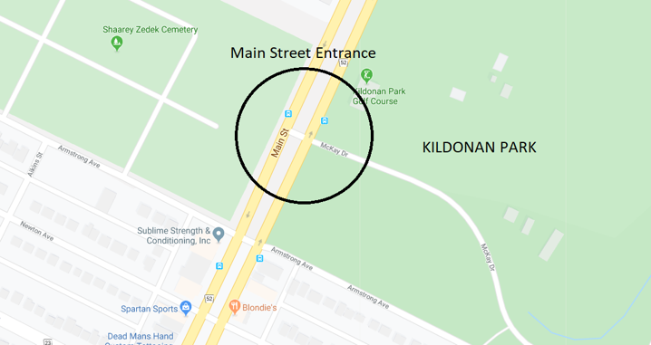
You can enter the park from Main Street

The road inside the park is called McKay Drive.

It is built in a loop shape and once you enter, you can continue to drive on the same road the whole way through the park. This road will lead you back to the gate to exit from.

While driving through the park you will pass a building and gardens on your left side.

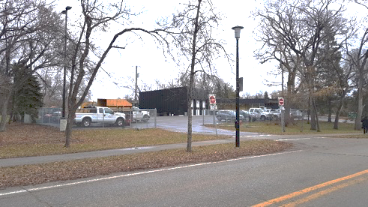

You’ll later pass a children’s play structure. This is also on your left side.

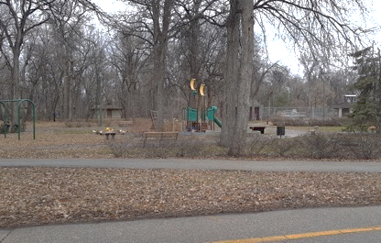

Rainbow Stage is located next to the Kildonan Park Pool and Playground that is located on your left side.
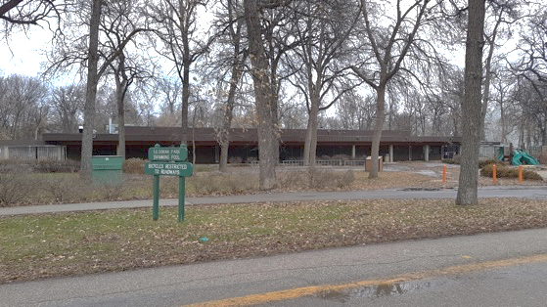

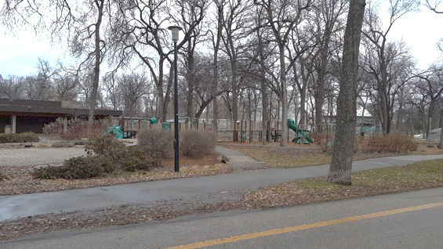

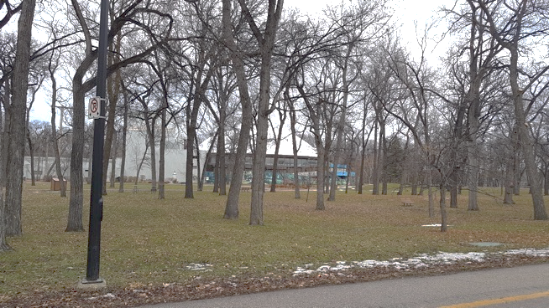
You will see this on your left side shortly after passing the playground

You can also enter the park from a nearby side entrance

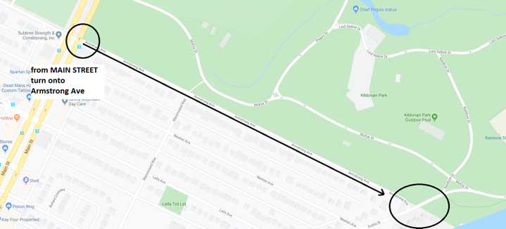

If you enter through this gate, you will first see the theatre like this.
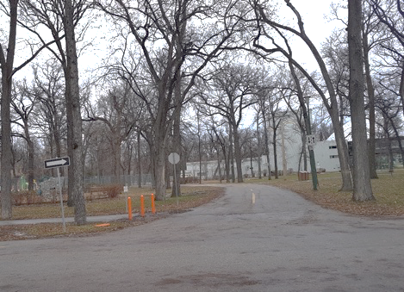

Turn RIGHT at this intersection

Parking Lot next to Rainbow Stage
Parking is FREE to all guests of the park.
There will be attendents (provided by The City of Winnipeg) stationed in the parking lot during Rainbow Stage productions to help guide drivers to the best parking spot.
There are limited handicap parking spots availa and those employees will guide you there.
Please have your valid handicap tag visible.
During busy show times, the parking is arranged using a trick called “STACKED PARKING”.
This means vehicles are parked very close together.
There will not be enough room to remove your vehicle until the production is over and all other guest have begun to leave the parking lot.

Finding the Parking Lot
While driving on the road inside the park (McKay Drive), you will pass the theatre on your left side.
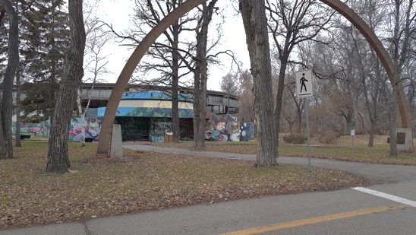

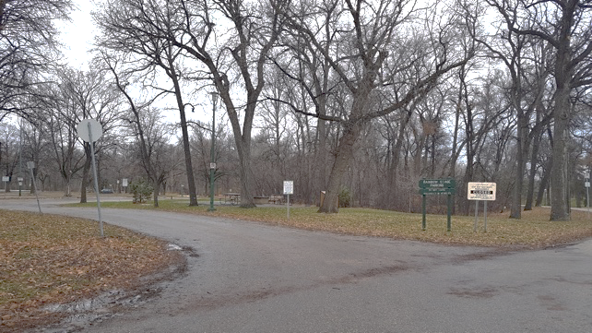
Next, you will see this, also on your left side

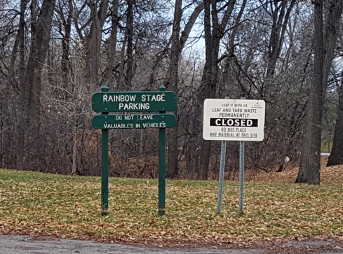
A closer view of the green sign reads, “Rainbow Stage Parking. Do Not Leave Valuables in Vehicles”

Enter the Parking Lot using this driveway

This is the front entrance to Rainbow Stage
It is also where you would pick up tickets that you have purchased in advance, or if you are looking to buy.
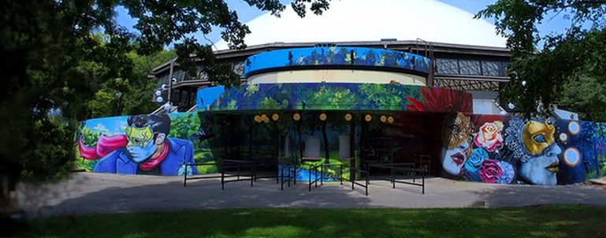

Please Be Aware
There are several NO PARKING and NO STOPPING signs on the road in front of the theatre. If you choose to park on the street, please watch for restrictions.

Many patrons choose to park on nearby Scotia Street for easy exit after the show.

Drop Off Points
There are two locations that allow for easy drop off of guests before parking.
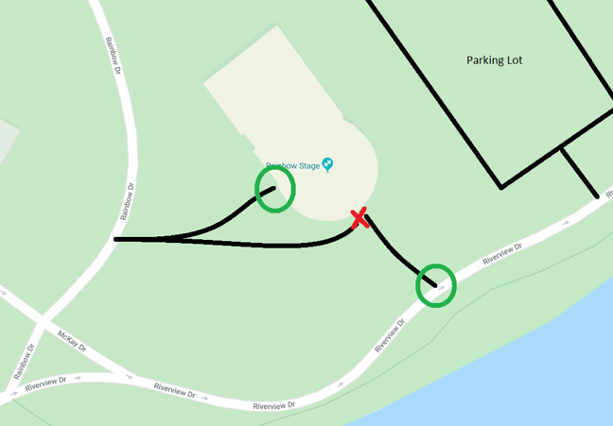
This is the sidewalk leading to the Front doors of the theatre – where all patrons are required to enter
This is a public sidewalk, and is often CROWDED. No vehicles are permitted. This is NOT a drop off zone
This is the Drop Off Zone on the south side of the theatre.

Please DO NOT drive on the sidewalk in front of the theatre.
This sidewalk is usually CROWDED and vehicles are not permitted, for saftey reasons.

