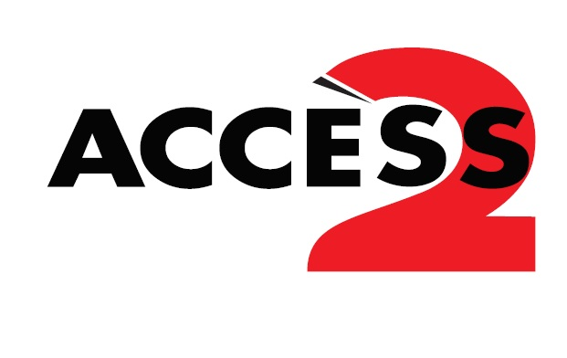

Presented by Easter Seals Canada, the Access 2 program exists to remove a barrier— the added admission cost for a support person — which often prevents people with disabilities from participating in cultural, recreational entertainment-related activities.

How the Program Works
The card grants 1 free admission for a support person, while the person with the disability (Access 2 cardholder) pays the regular admission fee.

When purchasing a ticket, the Access 2 cardholder must present a valid Access 2 card and may be asked for a piece of personal identification prior to purchasing their tickets. Both cardholder and support person must attend the event together.

Who is a Support Person?
“An adult who accompanies a person with a disability to assist them in fully participating in the entire movie theatre, museum, art gallery, attraction or recreational experience by providing the cardholder with those services that are not provided to them by venue/attraction employees.”

Program Conditions
Tickets must be purchased on the same day of use as early as two hours prior to the performance and with the attendant present. Unfortunately, at this time, advance ticket purchasing using the Access 2 Card is not available at Rainbow Stage.

All Access 2 cards have an expiry date printed on the front.
If the Access 2 Card is greater than one month expired, it will not be accepted.

Access 2 Cardholder tickets (at regular price) will qualify for any discounts or promotion codes that may apply. For information about our currently offered discounts and promotions, please visit www.rainbowstage.ca/sponsored-deals or call 204-989-0888.

Suspected Misuse
If Rainbow Stage suspects misuse of an Access 2 Card, the cardholder’s barcode may be recorded and provided to the Access 2 team who may investigate further.

If you are interested in learning more about the Access 2 program, please contact Easter Seals Canada www.access2card.ca

